**DEPARTMENT OF INFORMATION AND CORPORATE MANAGEMENT,**

**FINANCE AND INFORMATION MANAGEMENT**

**PROGRAMME TITLE:**INFORMATION AND COMMUNICATIONS TECHNOLOGY,

BUSINESS AND INFORMATION MANAGEMENT**,** ACCOUNTING, INTERNAL AUDITING, LIBRARY AND INFORMATION STUDIES

**PROGRAMME NAME: MOBILE COMPUTING**

|  |  |  |
| --- | --- | --- |
| **Name** | **Surname** | **Student No.** |
| Nkosenhle | Nkosi | 21941468 |
| Skhulile | Thabethe | 21901693 |
| Banele | Mngomezulu | 21919447 |
| Ruben | Mazibuko | 21927360 |

# Home page

The page below is our home page where we welcome clients who visit the website. The home page also displays our branches which are situated across the country.

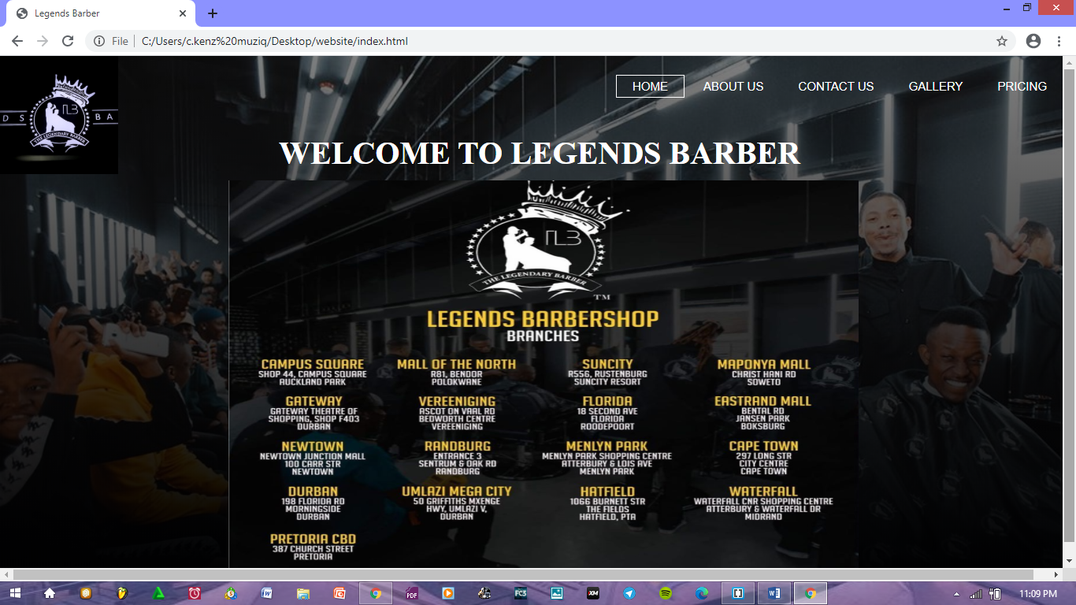

And the page below is the code behind our home page and the person responsible for it is Nkonzenhle Mazibuko.

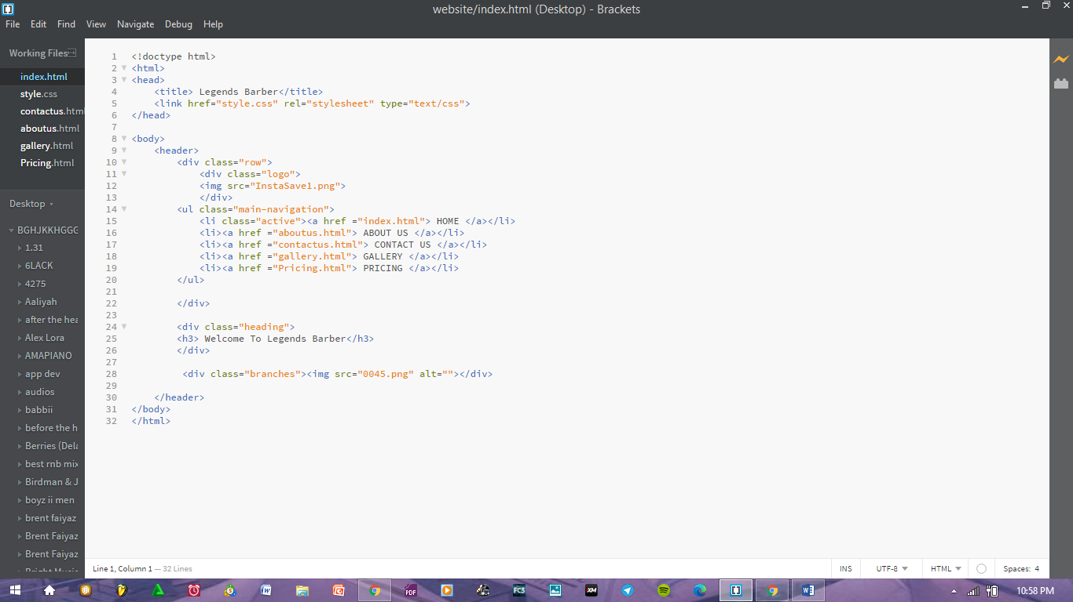

# About us page

The page below is our “About us” page where we briefly enlighten our potential clients about what Legends Barber is all about, our services and what we stand for. We also display our contact details.

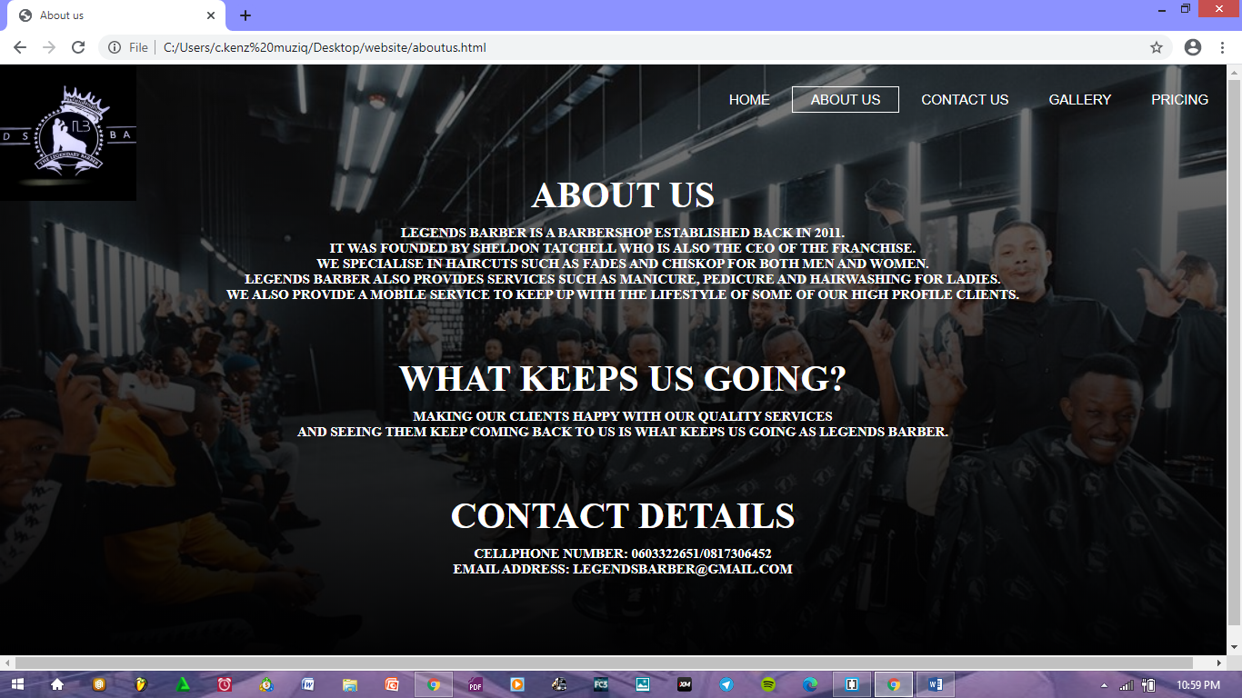

The page below is the code behind the “About us” page and the person responsible it is Skhulile Thabethe.

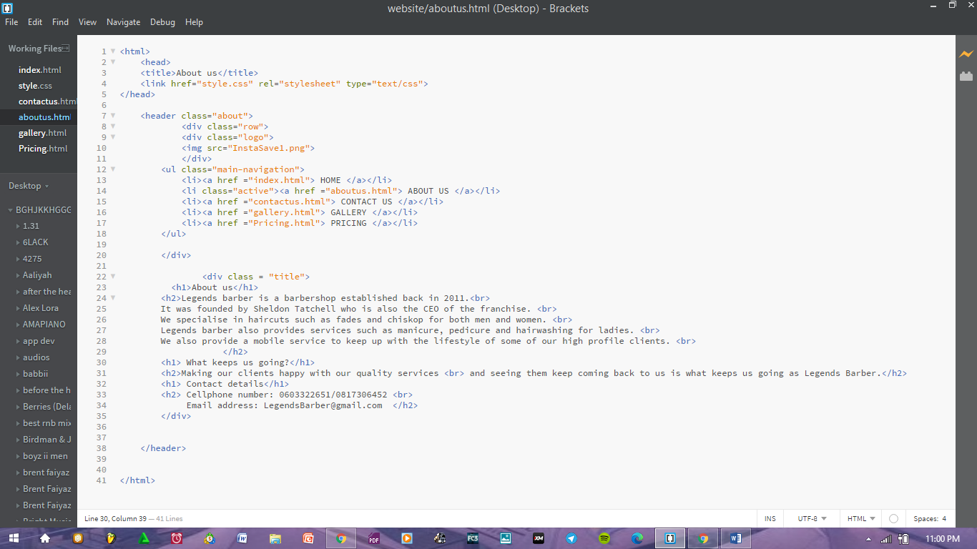

# Contact us page

The page below is our “Contact us” page where potential clients who want to make an appointment with us can do so by providing their details and then we will communicate with them thereafter.

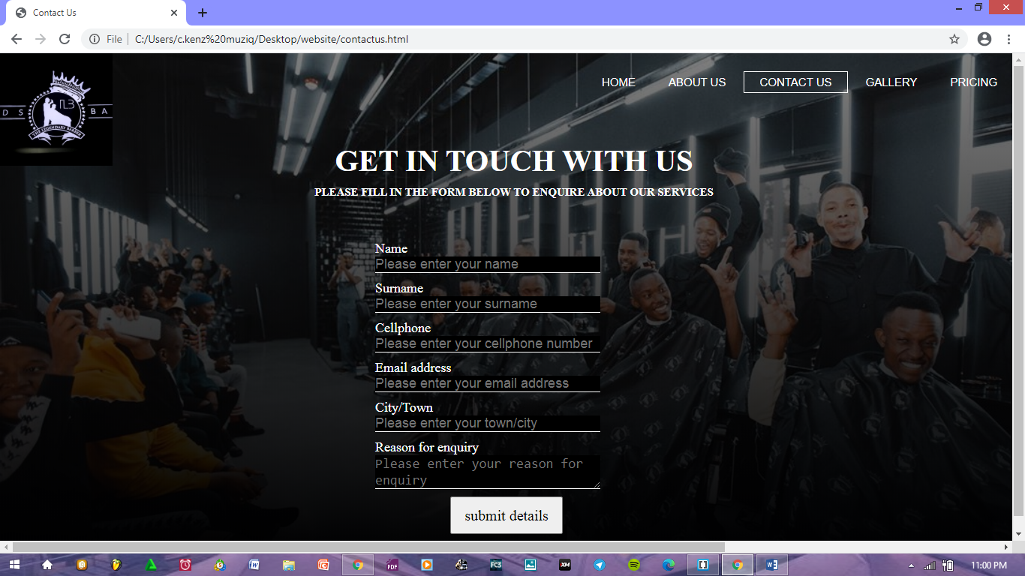

The page above is the code behind the “contact us” page and the person responsible for it is Nkosenhle Nkosi.

# Gallery page

The page below is our “Gallery page” where we display pictures of our clients in different hairstyles that we offer at Legends Barber.

# 

The page below is the code behind the gallery page and the person responsible for it is Nkosenhle Nkosi and Skhulile Thabethe

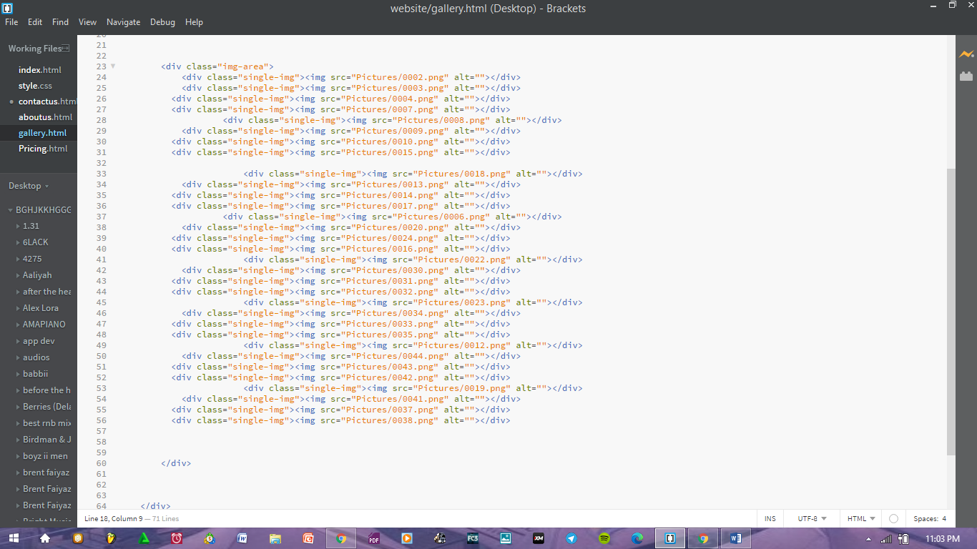

# Pricing page

The page below is our “Pricing” page where we display prices for the services that we offer.

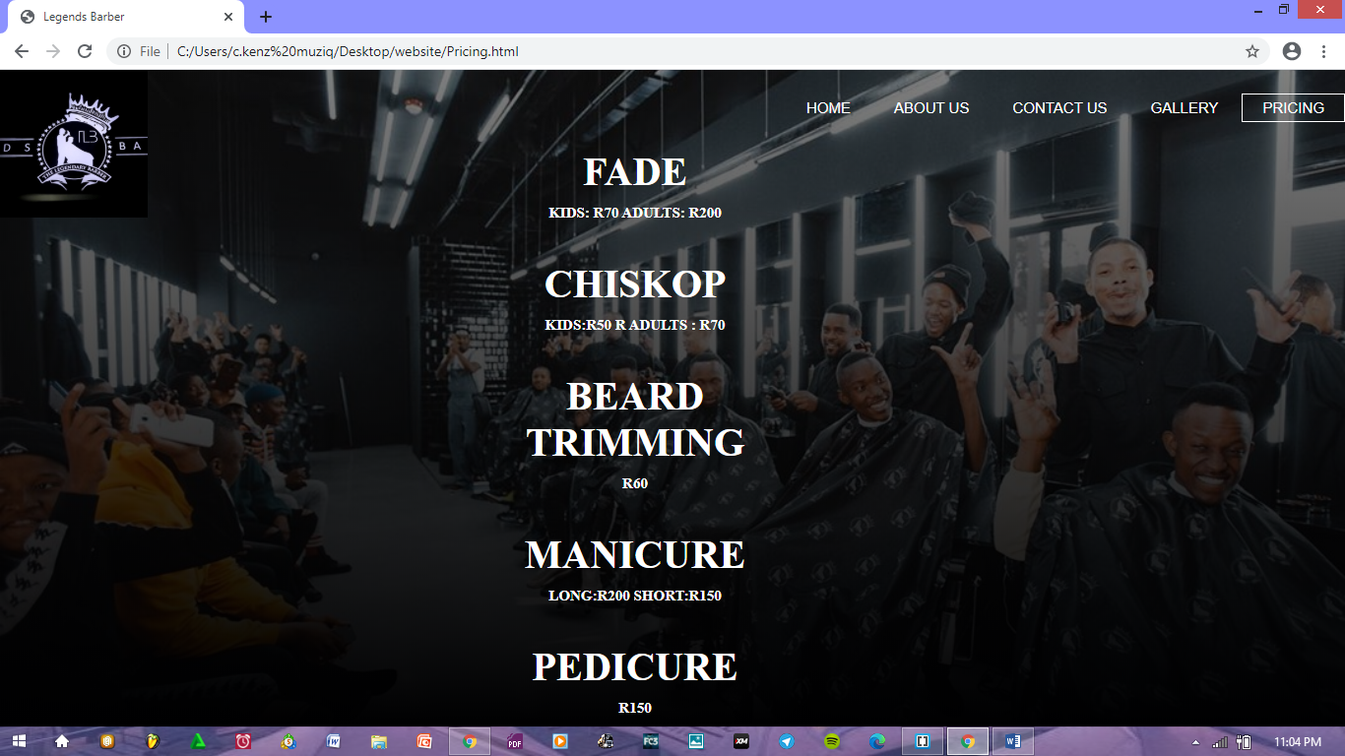

The page below is the code behind the pricing page and the person responsible for it is Banele Mngomezulu.

